Name: ___________________

HTML 5 ~ CSS 3
CONCEPTS REVIEW – Unit C

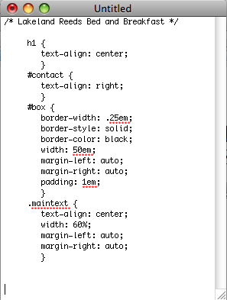
e
d
g
f
c
b
a

- Which item is the value assigned to a CSS property? A B C D E F G
- Which item is ignored by a user agent? A B C D E F G

- Which item specifies a set of presentation rules? A B C D E F G

- Which item is a CSS property? A B C D E F G

- Which selector is based on the value of an HTML id attribute? A B C D E F G

- Which selector is based on the value of an HTML class attribute? A B C D E F G

- Which selector is based on the name of an HTML element? A B C D E F G

Match each term with the statement that best describes it below.

_____ 8. style rule a. a selector that applies the specified name-value pairs
only to the elements with the specified id
_____ 9. name-value pair b. a line or block of CSS code that specifies the presentation
of Web page elements
_____ 10. embedded style sheet c. a selector that creates a style rule based on values
assigned to elements using the HTML class attribute
_____ 11. external style sheet d. the most general type of selector, which is the name of an
HTML element
_____ 12. type-selector e. a separate file containing style information that multiple
Web pages can link to
_____ 13. id selector f. a section of CSS code that specifies a CSS property to
apply to the selectors and the value to assign to the property
_____ 14. class selector g. a section of CSS code entered in the head element of an
HTML document

Select the best answer from the list of choices

_____ 15. Which part of a style rule identifies the HTML element or elements to which the style rule applies?
a. selector b. property c. value

_____ 16. A style rule ends with which of the following?
a. */ b. </style> c. ; d. }
_____ 17. A CSS comment ends with which of the following?
a. */ b. </style> c. ; d. }

_____ 18. A name-value pair ends with which of the following?
a. */ b. </style> c. ; d. }

_____ 19. An embedded style sheet ends with which of the following?
a. */ b. </style> c. ; d. }

_____ 20. Which is the most straightforward solution for affecting the presentation of a single Web page?
a. inline styles b. embedded style sheet
c. external style sheet d. div element

_____ 21. Which of the following enables you to modify the presentation of multiple Web pages with a single change?
a. inline styles b. embedded style sheet
c. external style sheet d. div element

_____ 22. Which of the following is a class selector?
a. text-align: right b. #lilac c. .ideas d. p

